## Request for Software Solution Architecture Proposal

## For

## Implementation of Mobile Banking Solution

## Background, Introduction and Disclaimer

Bank of Tritech is one of the largest Public Sector Banks in India and has international operations in 25 other countries. In India, the Bank consists of a branch network of 5000+ branches and 7500+ ATM’s. Bank of Tritech is known as India’s International Bank and has a reputation of being at the forefront in the usage of technology. While Bank has a vast network of Branches, Bank’s operations are fully automated and the customers of the Bank avail of various alternate channels of delivery.

Bank of Tritech, hereinafter referred to as the Bank has decided to automate regular banking operations in order to provide better experience to the customers. As part of this plan, Bank proposes to implement mobile banking solution, on CAPEX basis, to offer an innovative offering to attract the customers for continual usage of banking services through mobile handset. The proposed solution will be hosted in Banks Data Centre (DC) with Disaster Recovery (DR) site.

## Broad Scope of work

The COMPANYX would be responsible for implementation of an end-to-end mobile banking solution with required hardware, software, database, middleware, etc.

* COMPANYX to provide a composite solution of mobile banking services as Native/Hybrid/J2ME application to Bank’s customers with ability to work in all types of network/handsets, for e.g. GSM, CDMA, USSD/NUUP, Android, Windows, Symbian, RIM-based systems.

<https://ymedialabs.com/hybrid-vs-native-mobile-apps-the-answer-is-clear/>

* **A native app** is a smartphone application developed specifically for a mobile operating system (think Objective-C or Swift for iOS vs. Java for Android).
  + Faster
  + Good Look and Feel
  + Short learning curve for end user
  + Significant advantage of being able to easily access and utilize the built-in capabilities of the user’s device (e.g., GPS, address book, camera, etcetera).
  + *In short, native apps are exactly that, native to the user’s OS and hence built per those guidelines.*
* **Hybrid applications** are, at core, websites packaged into a native wrapper.
  + They look and feel like a native app, but ultimately outside of the basic frame of the application (typically restricted to the controls/navigational elements) they are fueled by a company’s website.
  + Basically, a hybrid app is a web app built using HTML5 and JavaScript wrapped in a native container which loads most of the information on the page as the user navigates through the application (Native apps instead download most of the content when the user first installs the app). Usual suspects here are Facebook, Twitter, Instagram, your mobile banking app, etcetera.

When to use Native or Hydrid?

>The choice is decided based on the time to market

Both hybrid and native approaches can get the job done but there are certain considerations that should be understood right off the bat.

**1.First, if a company can wait six months or more before the app is launched, a native approach makes the most sense. Native applications have the best performance, highest security, and best user experience.**

**2.However, if the desired time to market is less than six months, then hybrid could be a better alternative because the app can be built in one source code, can be released across platforms, and development time and effort is considerably less as compared to that of native applications.**

**3.Again, another word of caution. Your users will EXPECT a great experience. They do not care what approach your team decided to take. They will open the app and EXPECT it to be intuitive and responsive in terms of speed.**

**4.Overall, the performance of the app as well as the user experience vary significantly based on the development framework chosen, with the native app approach being the uncontested winner in both cases.**

**PERFORMANCE : Native vs Hybrid**

* Even the most vocal advocates of hybrid applications are forced to admit that native applications win the war in performance. A native app is faster and more reliable by its very design.
* As users navigate a native mobile app, the contents, structure, and visual elements are already on their phone, available for instant loading, and thereby providing a seamless experience.
* This is akin to downloading most of a website’s static content to a user’s phone at once which is then available for instant loading regardless of their phone’s internet speed.

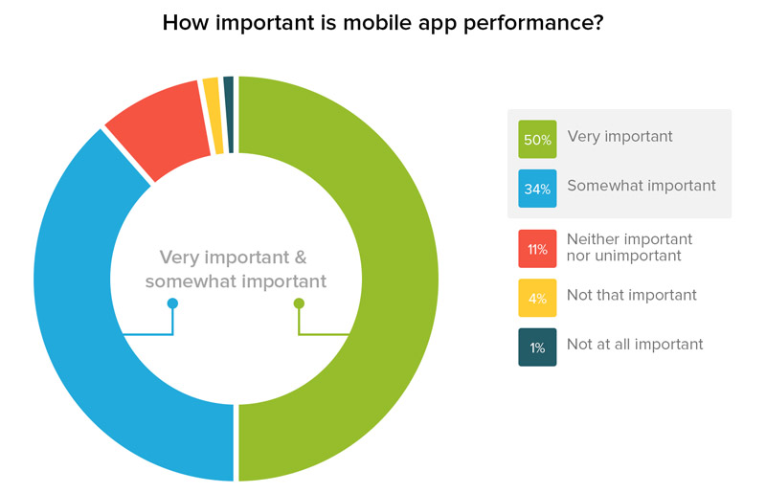

**Different type of mobile network**

<http://forums.pinstack.com/f24/network_types_explained_brief_gsm_gprs_cdma-362/>

1. **GSM (Global System for Mobile Communications)**
2. **GPRS (General Packet Radio Service)**
3. **CDMA (Code Division Multiple Access)**
4. **Mobitex (Two-way packet-switch network)**
5. **EDGE (Enhanced Data for Global Evolution)**

What is USSD?

http://searchnetworking.techtarget.com/definition/USSD

**What is NUUP?**

[**https://en.wikipedia.org/wiki/NUUP_Services**](https://en.wikipedia.org/wiki/NUUP_Services)

* The proposed Mobile banking solution should support facilities like IMPS (P2P, P2A, P2M, P2U etc.) funds transfer across Banks as well as intra bank, Mobile/DTH recharge, Utility Bill Payments, Ticket (Movie, Air, Railway) Booking, M-commerce, Card/Account to Card/Account Payments, necessary integration with NPCI (IMPS) and other payment aggregators for these services/various applications through Mobile Phones and should be enabled for Web based services.
* It should run on all types of handsets/TAB/Smart phone existing as well as new handsets coming in the market.
* Mobile banking application must conform to all the operational security guidelines prescribed by the Regulatory / Statutory bodies such as RBI, TRAI, and NPCI etc. which come into force from time to time.
* The mobile banking solution must be capable to work on varied communication modes and support GPRS, SMS, USSD and WAP based transactions with or without encryption as per the requirement of the Bank.
* The mobile banking solution has to interface with Bank’s Core banking application i.e. Finacle7.0.25, ATM Switch/any other middleware of the Bank with seamless parameterization and customization for successful implementation. The required customization at CBS/Switch end shall be done by the Bank.
* COMPANYX will be responsible for supply, installation and end to end implementation of Mobile Banking Solution, including customization, training to bank officials, etc.
* COMPANYX will bear cost of all Hardware / Software equipment’s, including duties and import cost required for this implementation.
* COMPANYX will provide user manual/media kit for application software, including manuals for operation, maintenance instruction, etc. CompanyX is required to submit two set of complete technical documentation, brochures, user manuals etc. in soft as well as hard copies. The documentation should include details regarding application architecture, database, network infrastructure requirements, and back-up and disaster recovery plan. All the manuals shall be in English and the documentations should be clearly indicative of the overall solution with architecture diagram.
* The solution should be designed with redundancy in mind to ensure nil impact by failure of one or more components / servers or software.
* The CompanyX has to provide support for troubleshooting and enhancements in the services during the contract period. Enhancement would include inclusion of all new browser/handset/ devices/mobile platform OS coming in the market within 1 month of their launch and also new market/industry related functionalities.
* The CompanyX has to provide and implement a tested and proven technology, end -to-end solution on turnkey basis for the Mobile Banking Solution including but not limited to providing the required hardware, software, database, middleware etc.
* The required hardware and infrastructure would be installed at banks datacenter (DC and DR locations along with auto/manual synchronization). The solution should be configured with automatic replication to DR site with Recovery point objective (RPO) and Recovery time objective (RTO) as specified by the Bank’s policy, currently it is RPO for CBS interfaced application is 10 minutes and RTO is 2 hours. The selected CompanyX has to ensure flawless switching of all the services under purview of this RFP to Disaster Recovery (DR) site during DR drill as and when decided by Bank or in case of non- availability of primary DC site.
* The solution offered should comply with all the Operative Guidelines for Mobile Banking Transactions in India issued by RBI vide circulars no.DPSS.CO.No.619/02.23.02/2008-09 dated 08/10/2008, DPSS.CO.No.2502/02-23/02/2010-11 dated 04/05/2011, DPSS.CO.PD.MobileBanking. No/02.23.001/2013-14 dated 01/07/2013 & Appendix and DPSS.CO.PDNo.1098/02.23.02/2011-12 dated 22/12/2011, RBI/2014-15/337DPSS.CO.PD.No.1017/02.23.001/2014-2015 dated 04/12/2014, RBI/2014-15/104 DPSS.CO.PD. Mobile Banking. No. 2/02.23.001/2014-15 dated 01.07.2014, RBI/2013-14/116 DPSS.CO.PD.MobileBanking.No./02.23.001/2013-14 dated 01.07.2013 and Report of the Technical Committee on Mobile Banking dated 07/02/2014, Report Customizing Mobile Banking in India : Issues and Challenges by Harun R. Khan dated 11.10.2012& 05.09.2012, M-Banking in India - Regulations and Rationale by K. C. Chakrabarty dated 09/04/2012& 29/03/2012. The solution should also comply with any further guidelines and mandates issued by RBI for Mobile Banking Transactions. The CompanyX has to undertake to incorporate, at no cost to the Bank, suitable changes in the solution including the software, procedure and operations as required from time to time to comply with any new rules of Indian Law from RBI/IBA/MFI/TRAI/Govt. of India/NPCI and other Regulators for providing the Mobile Banking services.
* Mobile Banking solution should be reliable, scalable, robust and readily deployable with minimum customization in compliance to all security features. Conform to ACID (Atomicity, Consistency, Isolation, and Durability) properties and non-repudiation.
* Tritech reserves the right to extend Mobile Banking services to Bank’s sponsored Regional Rural Banks (RRB), subsidiaries/associates with same terms and conditions. The CompanyX to factor-in enterprise wide application licensing. Only hardware upgrade, new customization and implementation charges would be discussed if bank decides to deploy the same to its RRB’s, subsidiaries/associates or other offices.
* The CompanyX should provide a Composite solution for both retail and corporate customers. Initially the retail solution will be implemented and in a phased manner corporate solution will be executed. The implementation modalities would be discussed between bank and the selected vendor for a smooth transition.
* Mobile banking solution should work on multi-layered architecture (Web & Application server, Operating System, Database).
* The CompanyX should provide Administrator Web portal for accessing customer records / transaction query with proper risk mitigation measures – configuring limits, velocity check, volume check, per day/monthly transaction limit check, fraud check etc. Administrator web portal will be accessed by Bank’s operations team, support team and Contact Centre agents with specified role and privileges.
* The Administrator Web portal should generate MIS/settlement report for reconciliation including IMPS.
* The CompanyX to offer a mobile development platform as an optional line item. Procurement of such type of mobile development platform is to enable Bank IT team to consider internal development activity, if required.
* The CompanyX should propose to offer active support to enhance activation and usage of mobile banking by Bank’s customer. The CompanyX can suggest criteria for incentivizing the customers and its monitoring.
* CompanyX has to provide performance monitoring dashboard, complaint portal and all reports as per formats required by Bank

## Centralized Call Login Facility and web based solution

The CompanyX should provide a centralized web-based call login facility for reporting any problem faced during download, registration, activation, and usage and/or report generation by Bank staff, Contact Centre agents or customers. The portal should have a built-in ticketing system with auto generation of ticket reference numbers with approximate time for resolution. The system should also have in-built capability to send an email and SMS to the customer with details on support ticket generation.

The Vendor should provide a dashboard for uptime checking, registration, activation and usage related reports. The dashboard should consist of reports, pictorial representation and other performance/transaction monitoring parameters.

## Deliverables

The Architecture Description Document should be complete in all respects and contain information asked for in this document. It is mandatory to submit the details in the standard formats duly filled in, as part of the offer. The Tritech , at its discretion, may not evaluate a document in case of non-submission or partial submission of architectural details. The Proposal must be submitted in an organized and structured manner and no brochures/leaflets etc. should be submitted in loose form.

The Proposal should comprise of following:

* Functional Specifications
* Non-Functional Requirements
* Documentation (HLD, LLD, technical specification etc.) to provide complete information of the solution offered to the bank as part of this RFP.
* Technical specifications and documentation of the solution including architecture and interfacing details with bank’s host system.
* Technology Choices
* All relevant documents that will confirms the concerns of stockholders
* Build or Buy Options

All the deliverables items will have to be completed and delivered within 60 days from the date of issuance of this document.

Once the received documents with functional specifications have been evaluated, the Tritech would short-list the Best Proposal, who qualifies for the Certificate. The Tritech may request further clarifications, presentations, reference etc. to have clear understanding of the architecture capabilities.